Project Report

1. **Introduction:**
   1. overview:

# Designing a logo with canva

Logo, a visual communication tool to help you get your message across to the audience.

## purpose

Logo are a point of identiﬁcation they're the symbol that customers use to recognise your brand

1. **Problem deflnition and design thinking:**

## Empathy map:

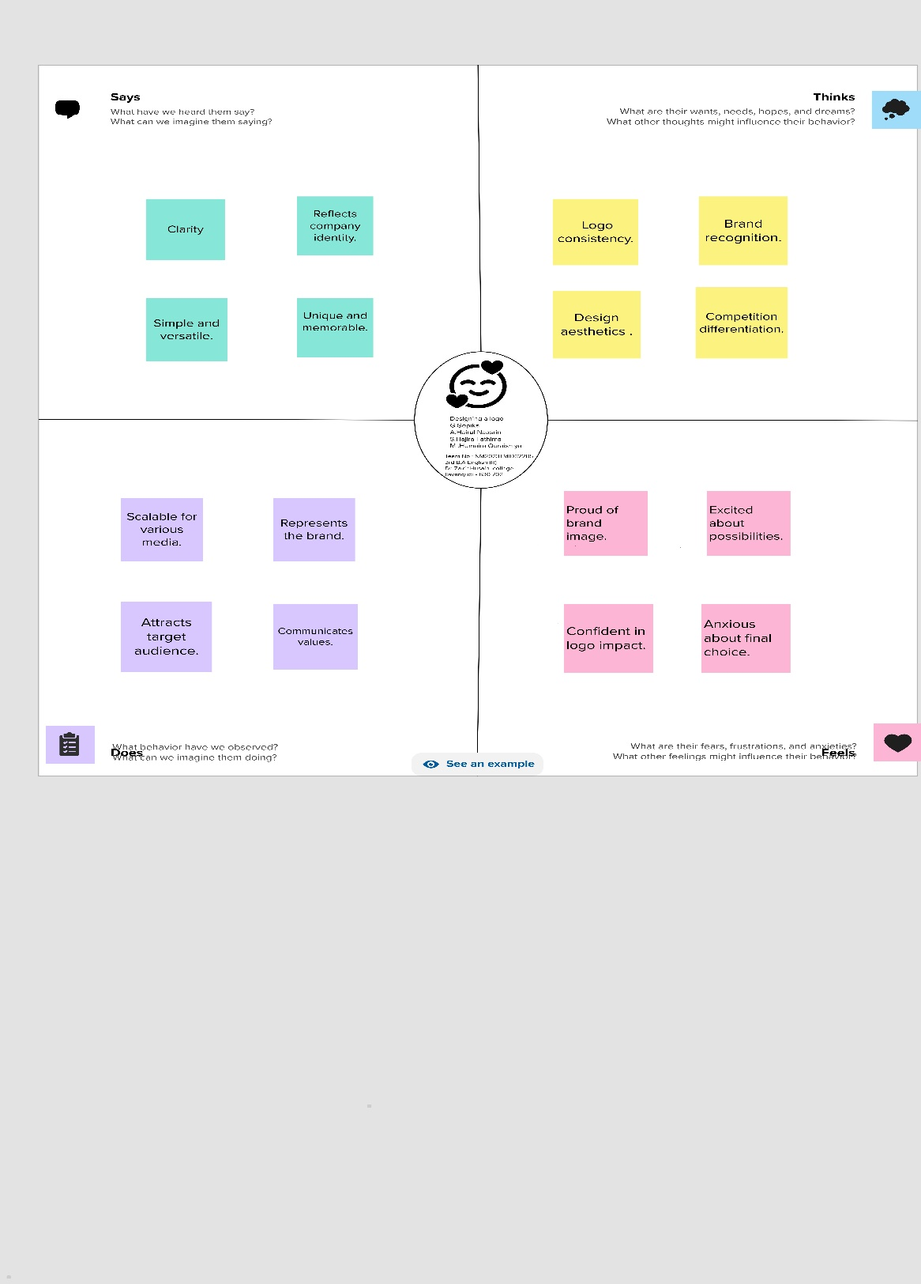

* 1. Ideation & Brainstorming map:

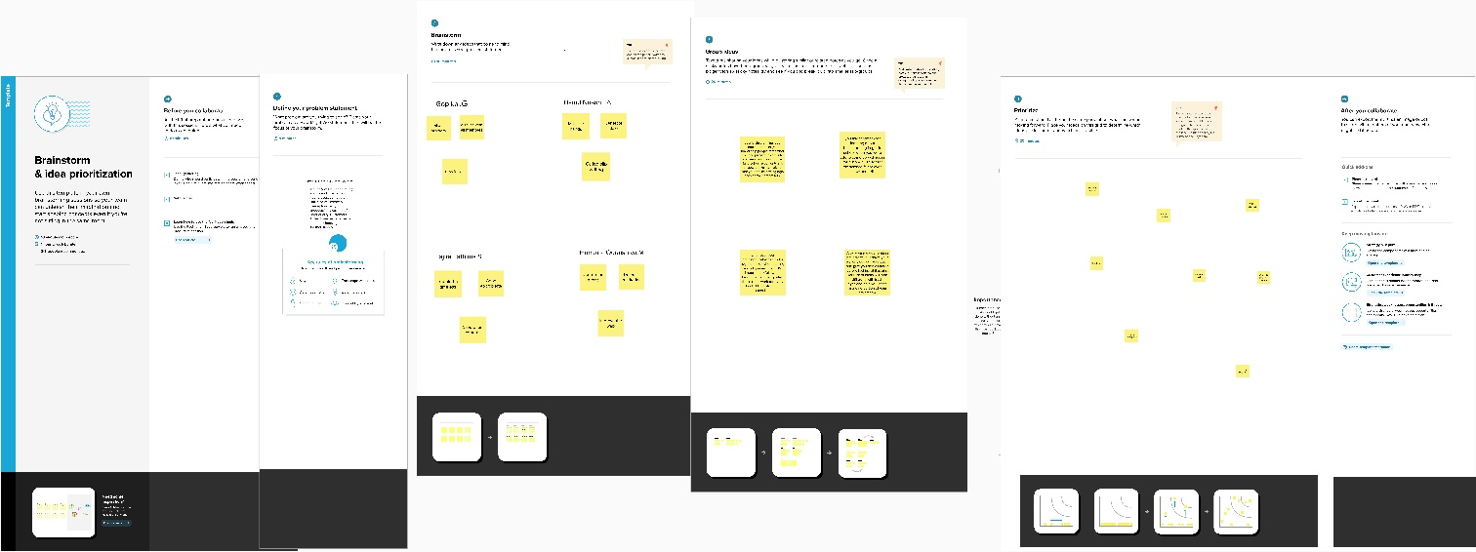

# Result:



1. **Advantages and Disadvantages:**

## Advantages:

Even a non-designer can become designer using canva Templates can be Altered to be more custom

Canva canva offer a professional look

## Disadvantages:

The free version is limited

Unique element cannot be created

# Application:

We create a canva account choose our template Background image and we use different fonts We add some elements and slogan

We create a logo

Finally we downloaded a design.

# Conclusion:

Logo design is an essential component of any business's branding strategy.